Install docker compose and create project structure
Note: We'll reuse app.py, requirements.txt from Practical 13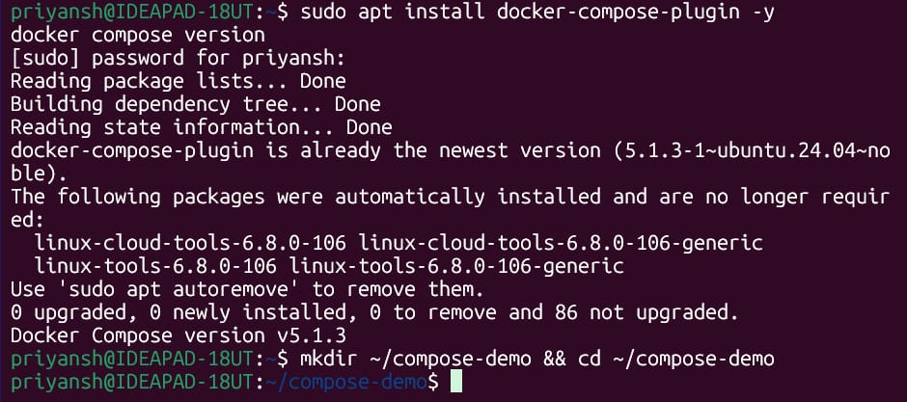
Use the given script in the corresponding file types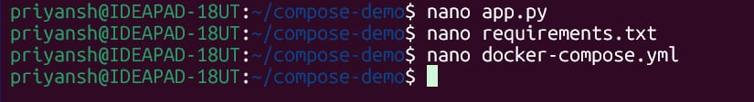
app.py - script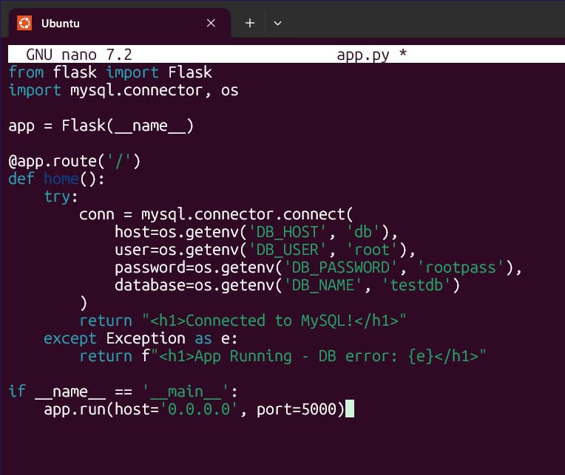
requirements.txt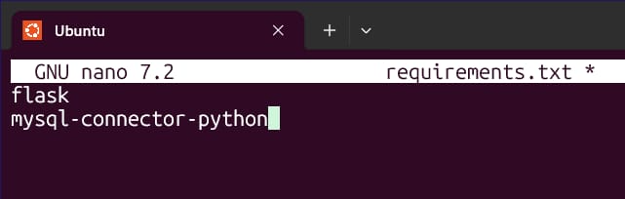
docker-compose.yml – script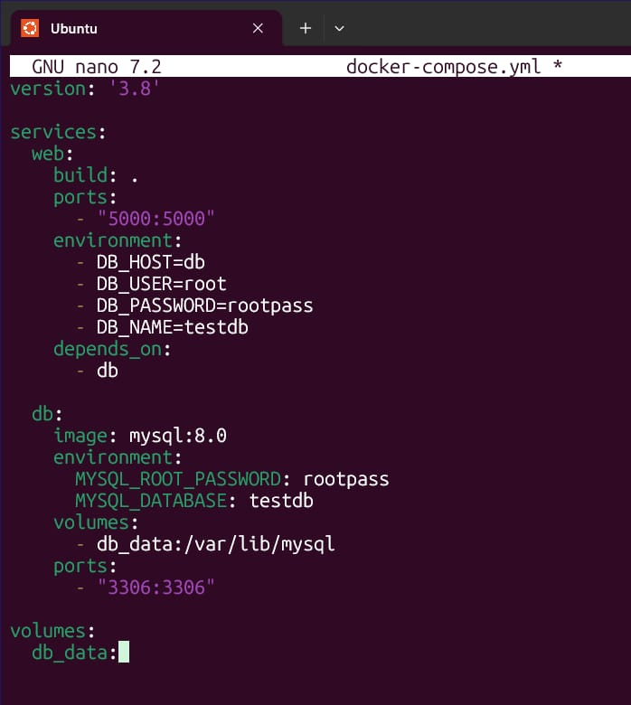
Start services, check them and logs for web service and DB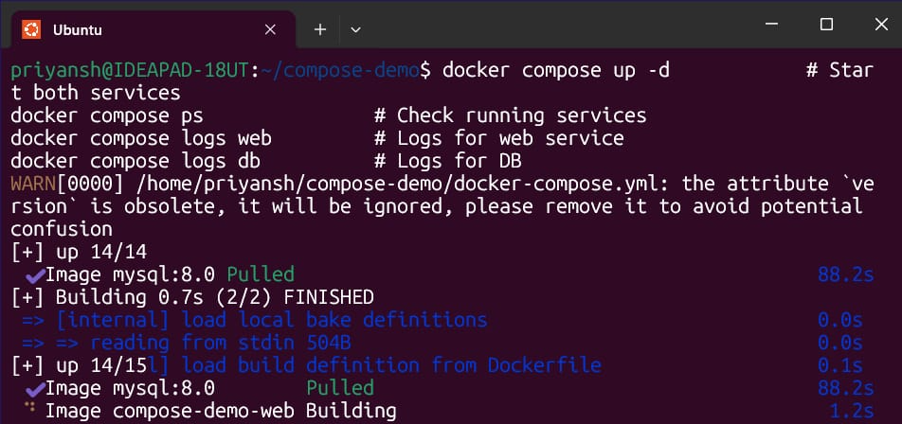
Scale up the instances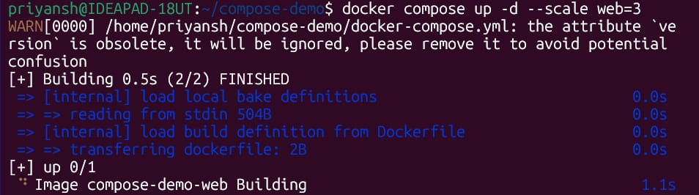
Stop all, then stop and remove containers and volumes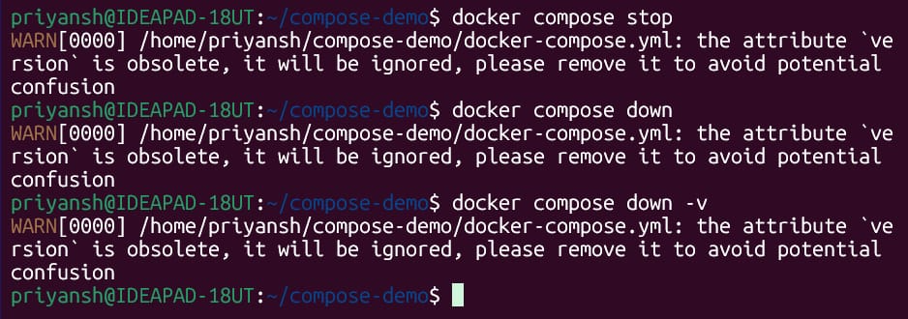
Once done, type exit to exit the terminal.

